1. Uploaded project does not show up (tutorial 3.1.2)  
   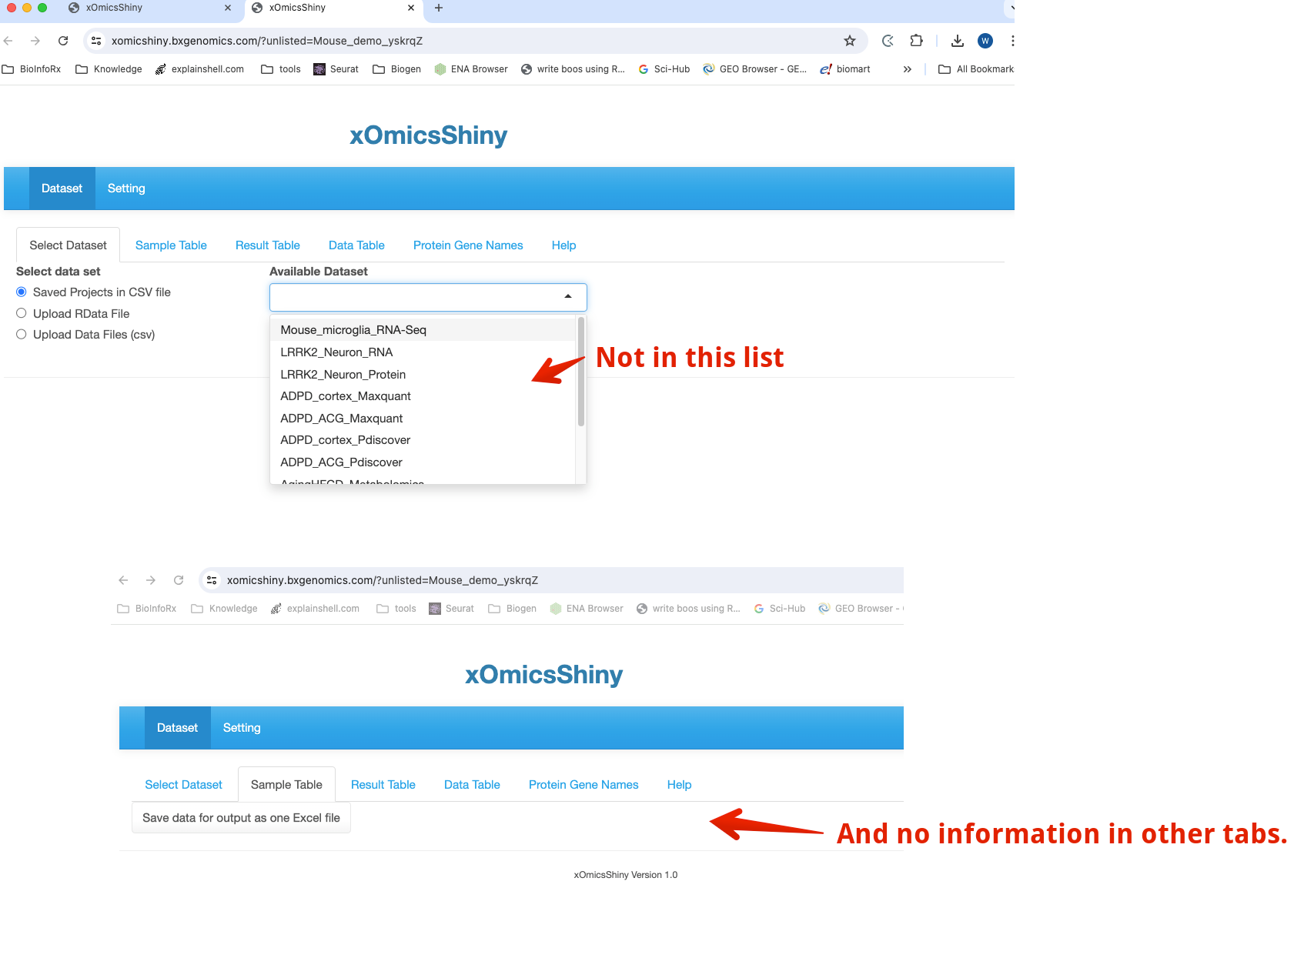
2. The sample table is not shown properly. (should remove Order and ComparePairs columns) (tutorial 3.2)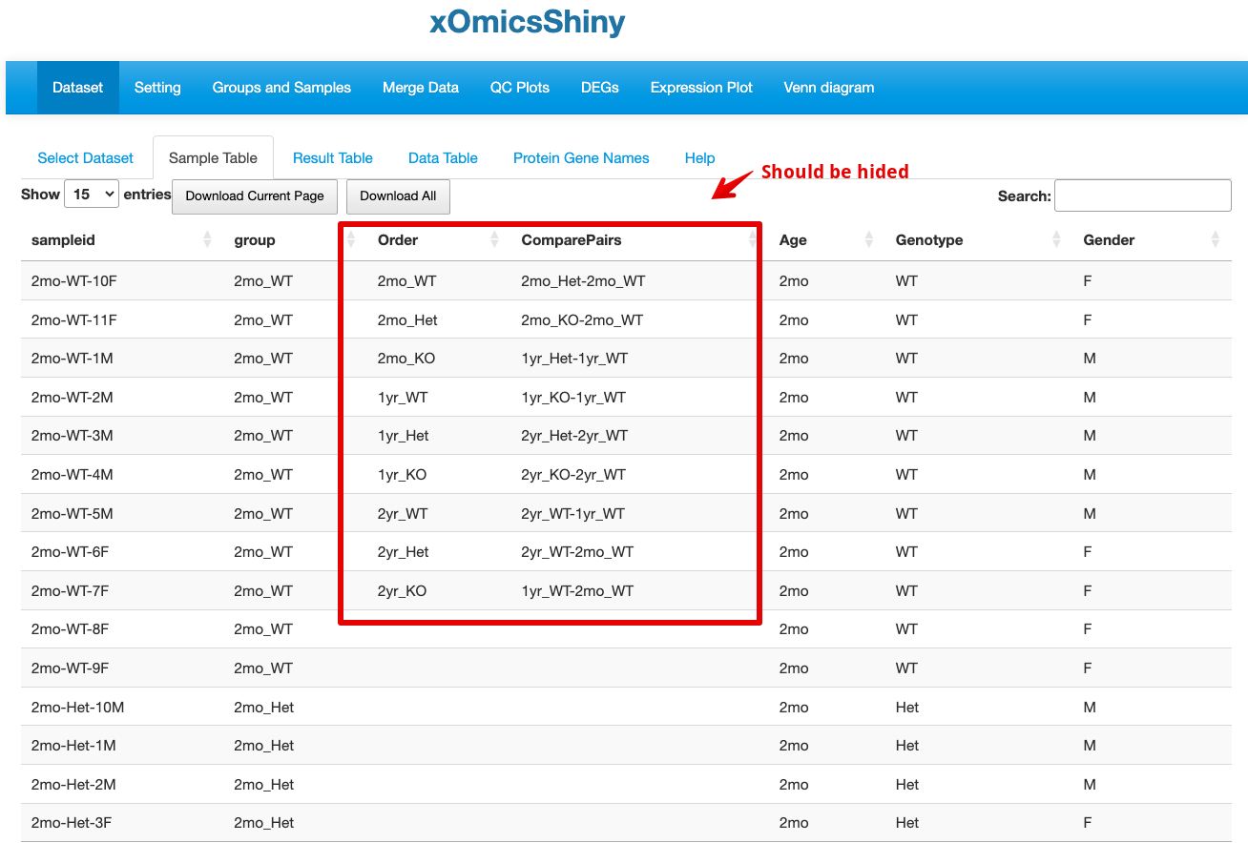  
     
   This is what QuickOmics show:  
   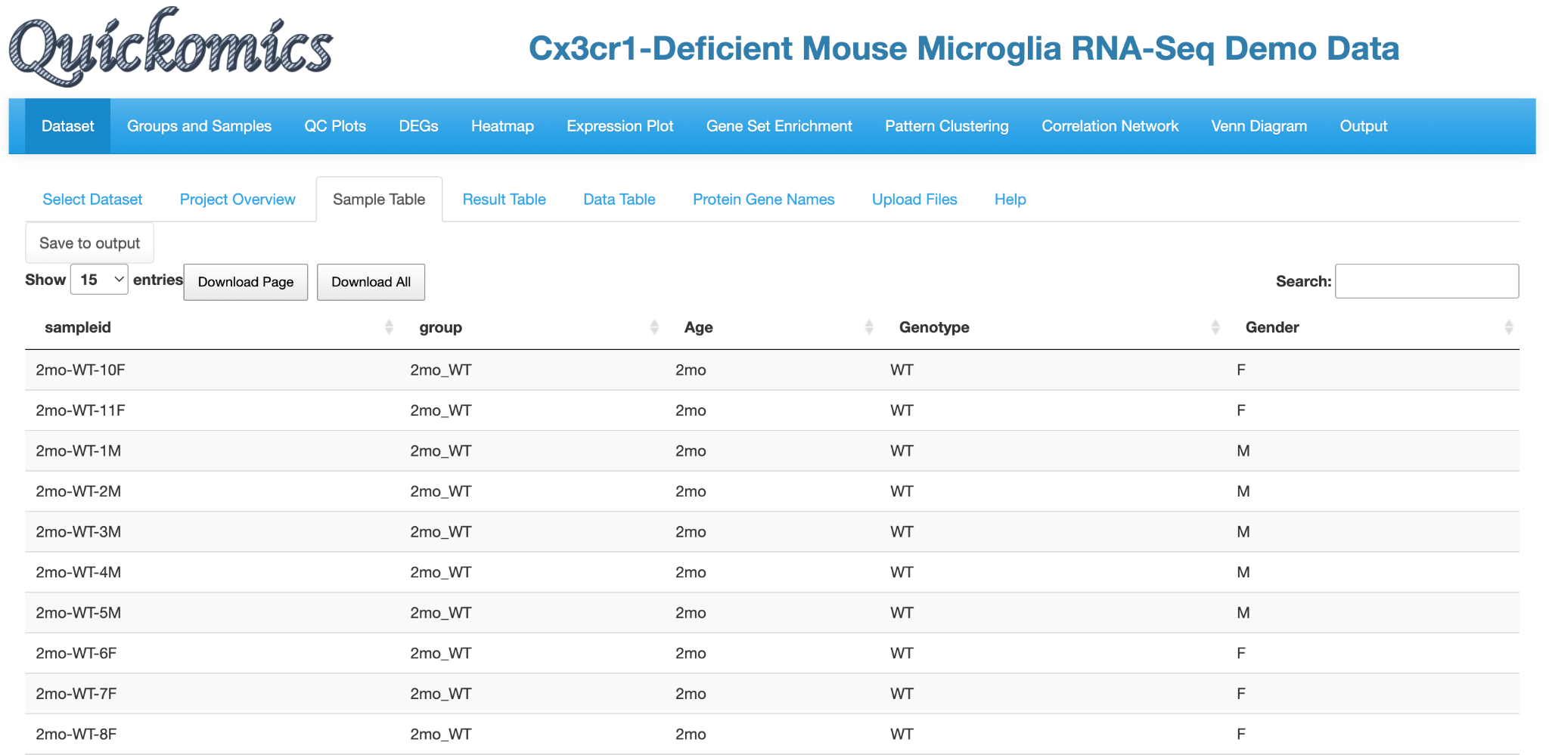
3. Same AgingHFCD_RNAseq dataset, Age_Group and Treatment were shown to be required in the form of a factor variable in order to be used as the “Color By” group for PCA 3D Plot.   
   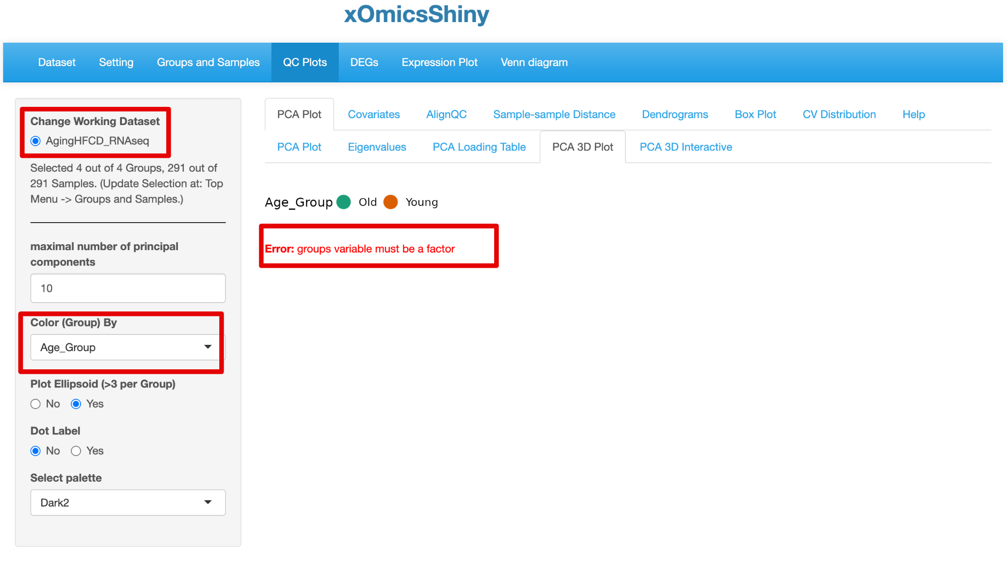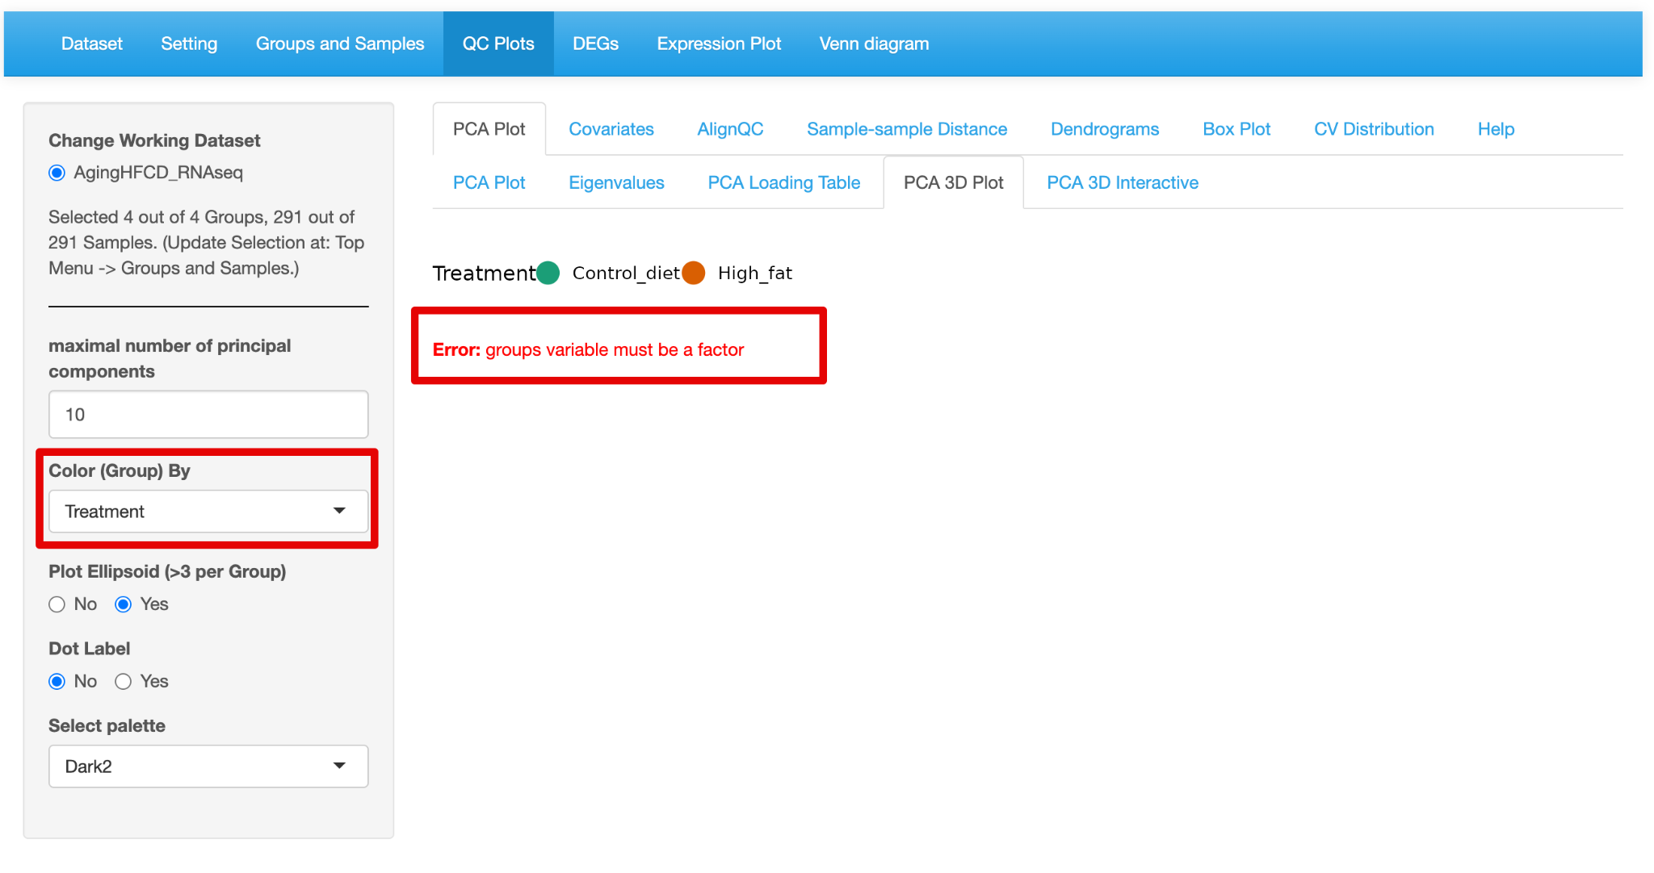
4. Expression plot module. (tutorial 8.1)  
     
   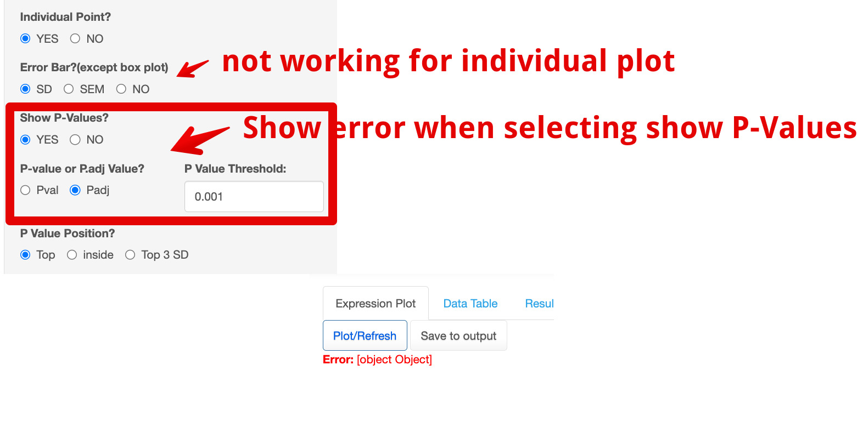
5. GeneSet Analysis module
   1. Species information is wrong for both proteomics and metabolomics data for both GSEA and ORA analysis.  
      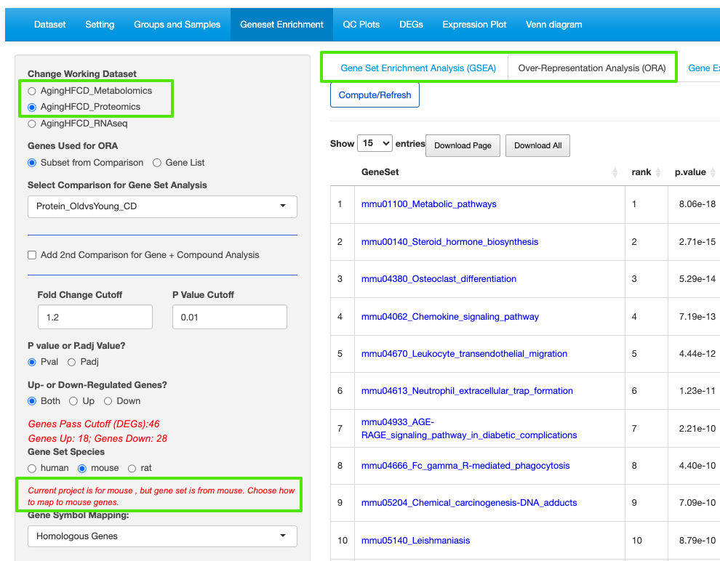
   2. ORA analysis result table using Gene list is not clickable.  
      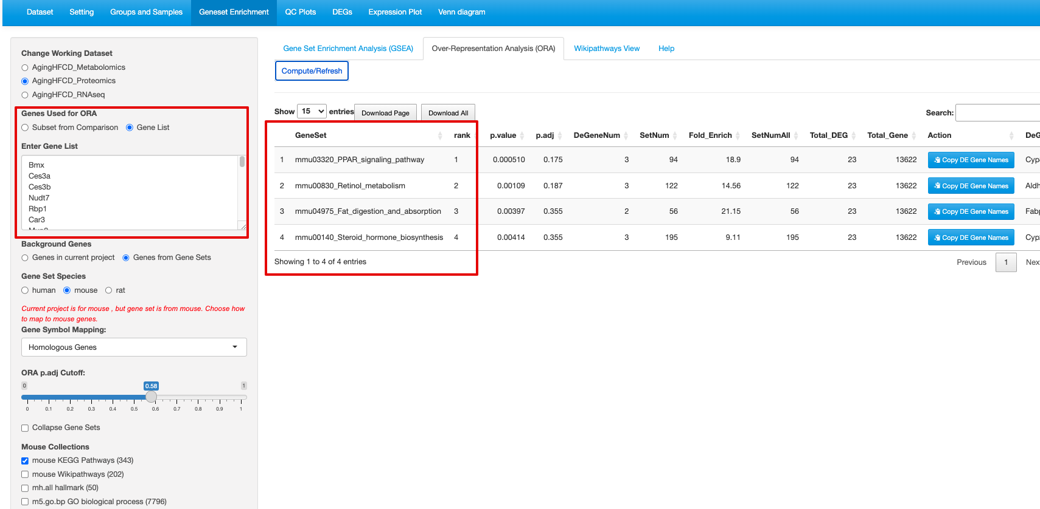
6. Pattern module (tutorial 10)
   1. Number of filtered gene does not match  
      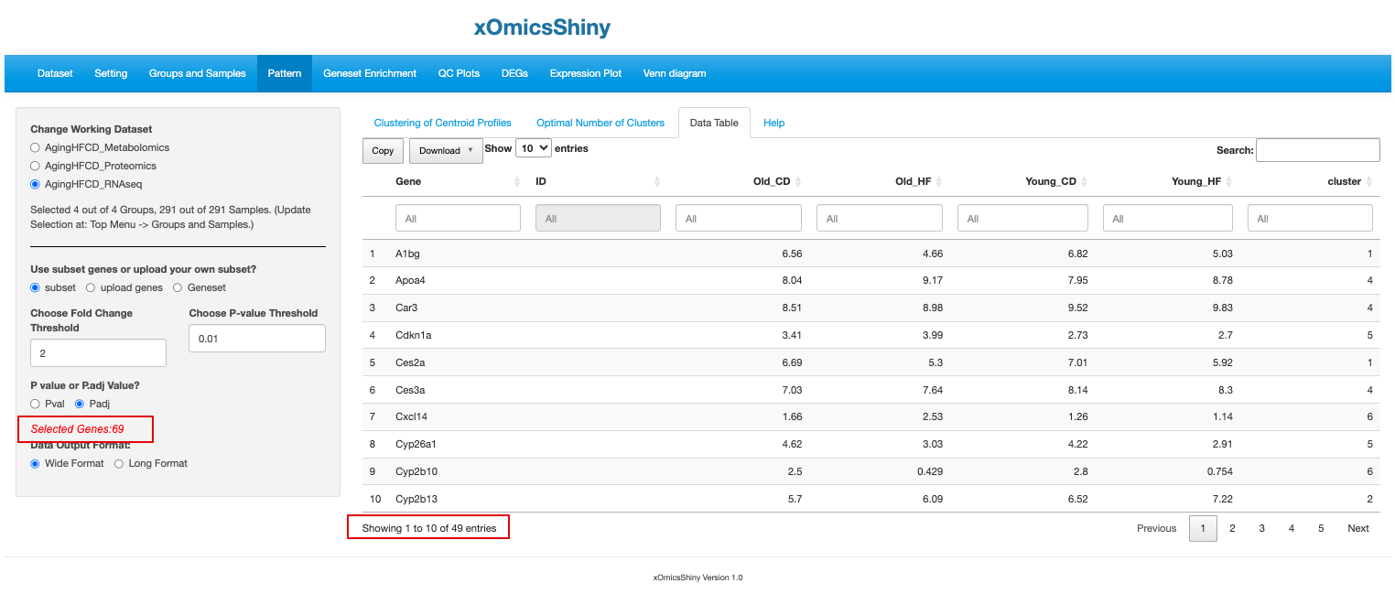
   2. Soft Clustering plot does not show correct number of lines(genes)  
      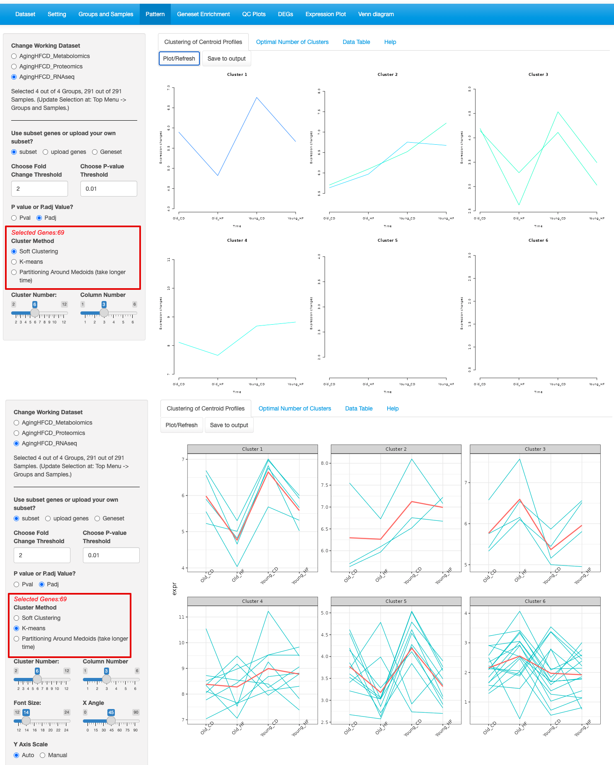
7. Dose response module
   1. Result table does not match.  
      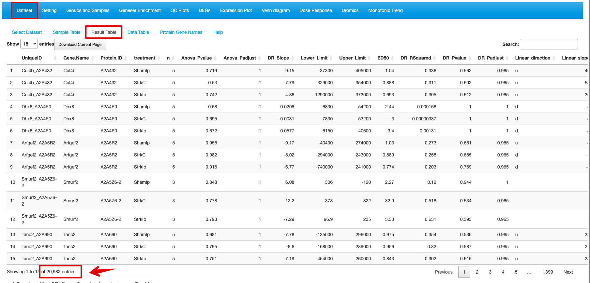  
      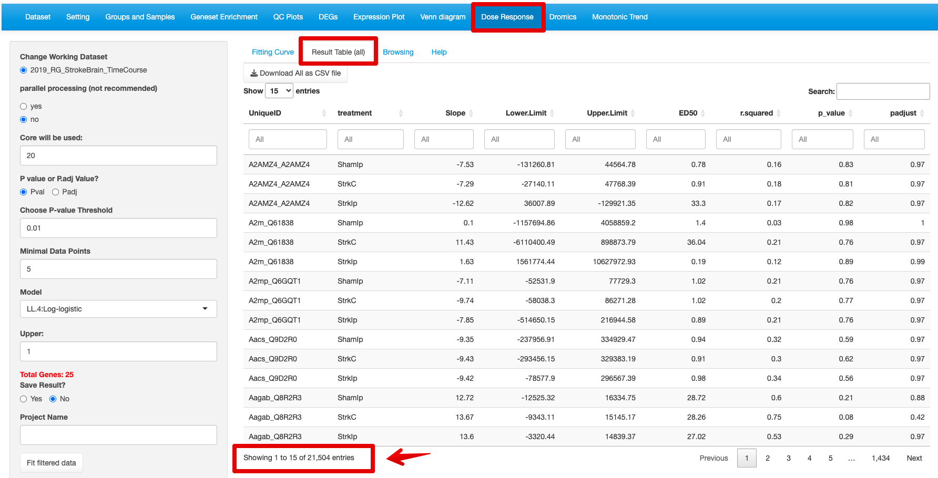
   2. Data Table is missing in the dataset tab.  
      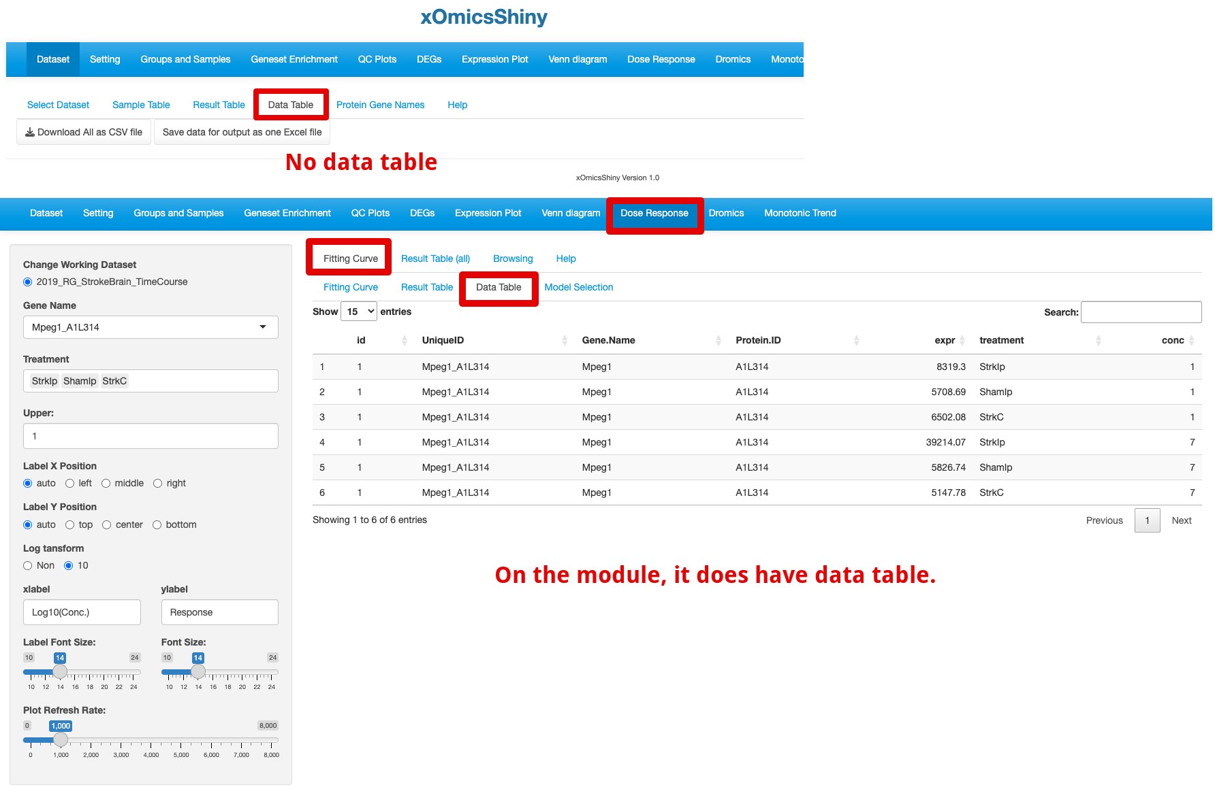

1. Time course Browsing tab is not working. (tutorial 16.3)  
   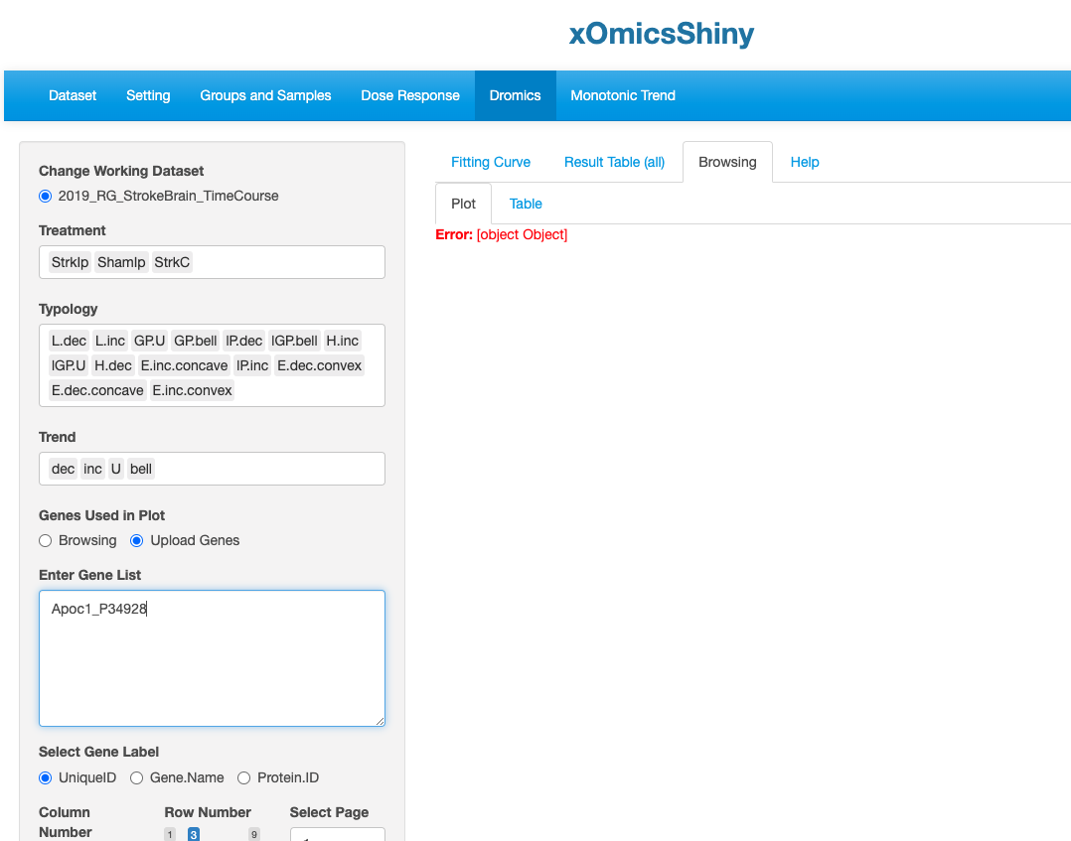
2. PCSF module, designed to do mapping to human database ?